**Spirituality Across the Curriculum**

**Lythe C of E VC Primary School**

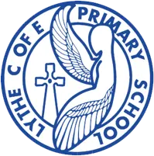

‘Be the best you can be and let your light shine’.

‘You are the salt of the earth… you are the light of the world.’

Jesus speaking in Matthew Chapter 5

**Spiritual development relates to fundamental questions about the meaning and purpose of life.**

Here at Lythe CEVC, we have thought long and hard about what spirituality means for our children, as well as our staff and whole school community.   Spirituality is a very personal experience. It differs from person to person and often spirituality changes within people during their lifetime. Spirituality is not the same as having a religion or faith; a person can be spiritual without having a particular faith. A focus on spirituality enables our children to be happy, to flourish and to live life in all its fullness.

At Lythe CEVC we use age appropriate language to define spirituality, so when talking to our children we will refer to a sense of awe and wonder – including a sense of fascination and enjoyment in learning about themselves, others and the world around them including caring for nature and living things. We use imagination and creativity in their learning and a willingness to reflect on their experiences to help children make sense of the world around them.

As a church of England school, we also foster this spirituality as part of our daily acts of worship, where children are encouraged to reflect on the stories and find their own meanings in them.  Our worship times are unique and vary from class to class, meaning that over the time that a child is in school with us they can experience and participate in a variety or spiritual disciplines from prayer to meditation (and much more) and learn a little more about their own spiritual identity.

**What is Spirituality?**

Whilst the concept of spirituality is difficult to define, here at Lythe CEVC, our shared definition sees the concept as central to what makes us truly human. There is an understanding that there is much awe and wonder in the world, along with a sense that we are all part of something greater. In essence, it refers to a connectedness to and appreciation of the wider world and our place within it. Spirituality is felt within ourselves by individuals and so cannot be taught or measured - instead being something that needs to be nurtured and given the right conditions and space to grow. We acknowledge that spirituality is deeply personal and so we afford every individual with the space and opportunity to develop along their own spiritual journey.

At the Lythe CEVC our shared understanding of opportunities to encourage spiritual development draws upon the work of Liz Mills, who uses the windows, mirrors, doors analogy to support children’s understanding of spirituality and this provides a time where you can reflect on what you’ve learnt.

Liz Mills approach also uses the concept of a ring doughnut to explain Spirituality.  The Doughnut represents the Whole Child. The outer ring is the tangible (Mind and Body), the hole represents the intangible (Spirit) but if there was no hole it wouldn't be a doughnut.

**Our shared definition of 'Spirituality'**

*"A sense of connection to something bigger than ourselves, and it typically involves a search for meaning in life. As such, it is a universal human experience—something that touches us all."*

**OR**

***“Spirituality is not something we can see; it is something we feel inside ourselves. It is about awe and wonder, asking questions, inspiration and being aware of something ‘bigger’ outside of ourselves.”***

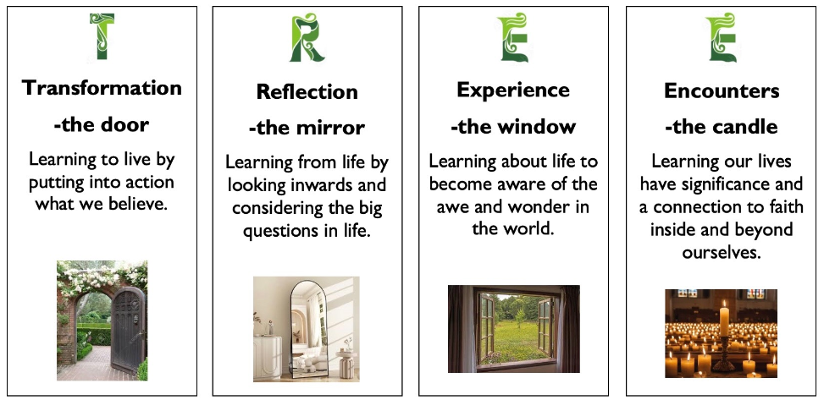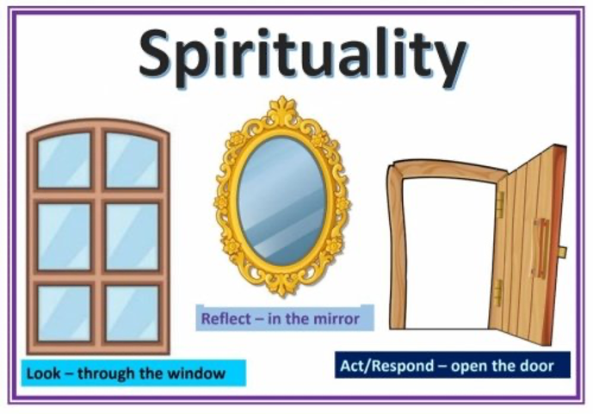

**Windows – LEARNING / REFLECTING**

Symbolised by a window. The learning element is when the Bible text is ‘opened up’ using a particular creative medium

* Opportunities for children to be aware of the world in new ways, looking out into the world.

* To wonder about life's 'WOWS. Things that are amazing.

* To think about life's 'OWS' that take us by surprise or bring us up short!

* Learning about life in all its fullness. This includes both the things that amaze them and also challenge them.

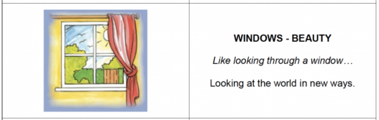

**Mirrors - Reflecting**Symbolised by the mirror. This element provides an opportunity for everyone to take time to consider how what they have heard, seen or felt has resonated with them or challenged them. For many centuries, stilling and centring have been central to Christian spirituality and in particular to prepare the heart and mind for prayer.

* Opportunities to reflect on their experiences.

* Looking inside yourself.

* Consider and meditate on life's big questions and consider some possible answers.

* Learning from life by exploring our own insights and perspectives and those of others.

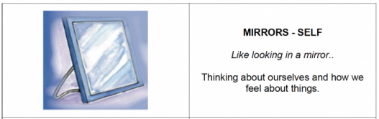

**Doors - RESPONDING**Symbolised by a door. This element is sometimes known as the ‘sending’ part of spirituality. It provides an opportunity to consider how those present might want to respond to what they have experienced and step out (as if through a door) of their comfort zone.

* Opportunities for children to respond to all of this.

* Moving onto a new path or situation.

* To do something creative as a means of expressing, applying and further developing their thoughts and convictions

* Learning to live by putting our beliefs and values into action.

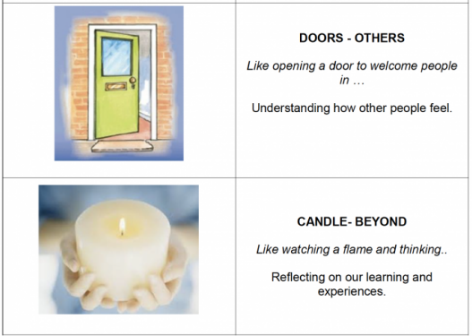

**The Candle**

This gives the opportunity to think about the things that you cannot see in life but you can feel. Your faith in God, love or imagination.



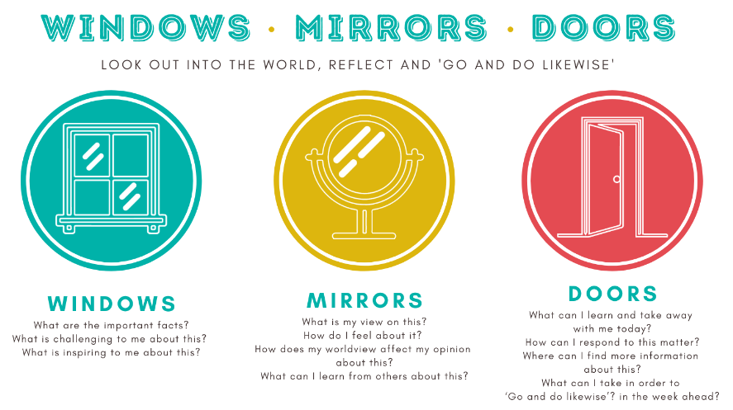

**Sprituality across the curriculum**

At Lythe CEVC, our school vision drives the curriculum and experiences we offer. We want all children and adults within our community to flourish, and we feel passionately about a broad curriculum which develops the whole child. We have explored as a community what spirituality means to us and how spiritual development is important in preparing children for later life, so they can be happy and fulfilled, to become responsible citizens.

**Reading**

At Lythe CEVC, we inspire spiritual development in reading by encouraging our children to read diverse, thought provoking texts which develop their ability to respectfully discuss, question and comprehend our world. In providing books to appeal to all interests and to reflect (and sometimes challenge) our values, we are broadening our children’s perspectives of the world, their empathy and understanding of each other, and their ability to respect different views, faiths and cultures. Reading takes our children on an exciting journey of discovery: whether diving into stories, firing-up imagination or the wonderful discovery of new facts. Importantly, our diverse reading curriculum helps our children to find (and reflect upon) their place in our world: spiritually, emotionally and socially.

**Writing**

Writing at Lythe CEVC allows the children to develop their spirituality by seeking a connection to an abstract concept in poetry or through stories. It also allows them to take action through sharing their personal thoughts or empathise with others through writing, role play and debating. Writing allows the children to be creative and use their imagination and to appreciate the beauty of language in a range of texts along with using language to express their understanding of the world around them (Both past and present).

**Maths**

In maths we promote spiritual development by promoting a mastery approach, enabling all children to learn and enjoy maths and deepen their understanding of key ideas needed to underpin future learning. Learning is supported and scaffolded through discussion, questioning and task. Collaboration is encouraged when exploring new concepts, where children support and value each others’ ideas to build stem sentences as an aid to learning. Noticing the positive and not criticising mistakes is promoted at all times. Our maths ‘working walls’ reflect the learning journey for new concepts and work is celebrated by displaying “what a good one looks like”. All pupils are encouraged to try open-ended “going deeper” tasks to celebrate their achievements.

**RE**

Spiritual development is an important part of our RE curriculum at Lythe CEVC. Through the Early Years RE curriculum, children are encouraged to marvel at the natural world around them through being introduced to the story of creation; thus leading to an ever increasing awe and wonder which will stay with them through their childhood. In Key Stage 1, spiritual development is promoted through developing natural curiosity and increased understanding of different religions such as Judaism and Hinduism. In Key Stage 2, children are encouraged to use questioning skills as they come across other religions such as Islam, as well as comparing the similarities and differences between religions already studied. Children are taught the skills to debate and question within RE lessons, developing their own unique worldview, as well as understanding and respecting that of others around them.

**Science**

At Lythe CEVC, we believe it's important to make links between spirituality and science education. Science naturally engenders a sense of awe and wonder from observing worms to being stunned by the results of a chemical reaction. We capitalise on this by providing opportunities for children to marvel at the natural world which promotes observational skills. We take this further by allowing children to speak to real scientists through enriching visits and visitors; for example to the local moorland with Tanya Eyre. These experiences open the doors for children to see how scientists observe, reflect and change their approaches during investigations. This naturally generates curiosity and the children ask questions about the beauty of the world around them. We nurture children to ask those big questions and find their own answers through science. As educators, we not only teach the facts but also aim for those WOW moments in and out of the classroom.

**History**

At Lythe CEVC we study history to learn about and learn from the past, being able to notice the differences and challenges faced by people in different periods of history. This fosters spiritual development by encouraging the children to be grateful for all freedoms and possibilities we enjoy today, in addition to learning big lessons from the highs and lows of our human history. We try to put ourselves in the other’s shoes as we step back in time and try to understand what life was like for people back then. Teaching history gives us the opportunity to celebrate the great achievements in our world, such as the first man on the Moon, Neil Armstrong. Children will have the opportunity to develop their own opinions from these lessons as we deepen our understanding of the world around us through human history. We can encourage spiritual development by inviting children to reflect and be proud of the part they can play in today’s history.

**Geography**

Geography is key in helping children to make sense of a complex and dynamically changing world. It is about how the world is formed and how it is changing. Following our school aim of ‘Being the best you can be’, we seek to help children to think about their place in the world. We want them to understand their responsibility to people and the environment whilst at the same time developing a sense of awe and wonder at the world which God has made for us to live in. At Lythe CEVC, our geography topics cover both physical and human geography. Over recent years, we have also sought to introduce children to the challenges of environmental geography and the responsibility that we all have to protect our planet.

**Art**

Our art curriculum supports spirituality of the world in many ways. The children look closely at the world around them and explore the closer details and natural beauty of the world through observational drawing. When using a variety of media, the children look closely at the properties of colours and how they resemble the world around them. We support the children to reflect on theirs and others work in art, responding respectfully to others. The children are encouraged to explore the styles of art and media that they enjoy.

**Design Technology**

At Lythe CEVC, we believe that through the study of design technology (DT), we can nurture the spiritual development of our children by giving them a variety of experiences which create awe and wonder and which have strong links with the world outside school. The study of DT encourages the exploration of ideas conceived by others, by considering what has already been created and the thoughts behind them; empathy by putting ourselves in the place of a client and curiosity by wondering how things can be improved. It also motivates and encourages the children to believe that they too can design something which could have a huge impact on the lives of others. Studying DT gives children the opportunity to consider how they can improve the world on a large or small scale and how they might do this with an environmental bias to help secure the Earth's resources for future generations. Children explore the impact their designs will have on the client through individual, paired or group work and are encouraged to be cooperative, creative and ambitious in designing the best solution to a problem within budget, resources and time constraints - much like those faced within real world scenarios. Children's confidence and self-esteem is boosted in these very practical lessons which some children find much more suited to their interests and skill sets than usual, less hands-on lessons. DT is a wonderful opportunity for all children to shine through its many faceted approach which positively encourages individuality and flair to be used in order to problem solve.

**Music**

'Praise him with trumpets. Praise him with harps and lyres. Praise him with drums and dancing. Praise him with harps and flutes. Praise him with cymbals. Praise him with loud cymbals. '

As we can see from Psalm 150 and throughout the psalms - music and spirituality go hand in hand. At Lythe CEVC we actively promote spiritual development through worship and singing praise to God. We celebrate as a school and community through our music and particularly our singing - and within the music curriculum we explore music from many cultures and discover the wonders of music through history. In the words of J.S.Bach 'I play the notes as they are written, but it is God who makes the music'.

**French**

At Lythe CEVC we believe that through the study of languages, we can nurture the spiritual development of our children by valuing and embracing other languages and cultures. The study of foreign languages encourages developing a sense of curiosity and empathy as well as the breaking down of barriers through the power of communication. Studying languages gives children the opportunity to consider ‘identity’ and what it means to them and others. Children explore emotions through language, reflect on different uses of language and they are often given the opportunity to use their imagination and creativity in groups and pair work. Teaching French promotes self-esteem by developing pupils’ confidence. As part of lessons, pupils are encouraged to: try new things including performing in front of their peers which promotes appreciation and support and work as part of a team.

**PE**

Spirituality within physical education (PE) is facilitated through mindfulness exercises, promoting a holistic approach to health and well-being. Children engage in reflective practices to connect their physical movements with their inner selves, fostering a deeper understanding of the mind-body connection. Dance sessions are incorporated into the curriculum, offering students a space to explore their spirituality through movement and breathing. Through activities like yoga or swimming, students learn to centre themselves and develop inner peace, enhancing their overall physical and mental health. The integration of spirituality in PE encourages students to cultivate a sense of gratitude, compassion, and self-awareness, enriching their educational experience beyond the physical realm.

**Outdoor Learning**

At Lythe CEVC we recognise that learning outdoors offers a unique opportunity to nurture the spiritual development of our children. By immersing themselves in nature, children learn to value and appreciate the diverse wonders of the world, fostering a sense of curiosity and empathy towards other living beings and ecosystems. Outdoor learning encourages children to be curious, observe the beauty all around us, and notice changes. These outdoor experiences often prompt children to ponder the unanswered questions and contemplate the world around them, encouraging a sense of connection to something greater than themselves.

**Computing**

It is easy to reflect on the awe of the universe when we examine the opportunities and possibilities that technology can provide us both now and in the future. In our computing lessons we encourage children to use their imagination and explore their creativity, creating code and presenting their ideas through a variety of different media. Children are encouraged to look beyond their screens to develop their computational thinking by solving problems in the real world. Furthermore, the impact and responsibility of our online interactions, how they affect a person’s spiritual development and sense of self, are themes that are explored extensively from reception to year 6.

**PSHE**

Our PSHE curriculum is structured around developing children’s understanding of themselves, others and the world around them. These are also key features of how we believe children’s spiritual development is nurtured. From finding out about their own bodies and how to keep themselves healthy, through learning how to get on with other people to becoming positive role models in school life and the wider community children are given many opportunities to wonder, reflect and inspire. Throughout the year there are also special occasions, such as Anti-Bullying week or Charity events where our children are encouraged to think deeply about the kind of person they are, the effect of their actions on others and how they can be real “agents of change” for issues they feel strongly about.

**Early Years**

At Lythe CEVC, we foster spirituality in the Early Years by marvelling at and caring for God’s creation from the tiny to the vast. Developing awareness of our place in the world, by thinking about other people as well as ourselves and our feelings and by sharing our home lives and cultures with our friends.

**Inclusion**

We celebrate and embrace diversity at Lythe CEVC. We recognise that all children learn in different ways and that we all have different skills and talents. We want all children to be respectful and listen to each others’ different views and understand that we all think differently. We will support children to recognise when they have different feelings and we have spaces around the school when we need time for peace and quiet.